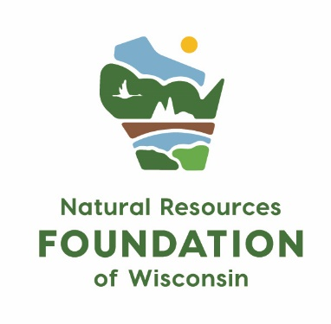
Grant Report Form

Instructions: Thank you for taking the time to share the impact of this funding from NRF! We will use this information to share stories of impact in our communications, and to share with our members and donors across the state.

Please send this report (in .doc or .pdf format) and 1-3 photographs (.jpg format) as attached files to NRFgrants@WisConservation.org. If you prefer to verbally share the impact of your grant, you’re welcome to set up a phone call with our NRF Grants Team instead of submitting a written report.

Project Overview

Project Title:

Organization:

Outcomes:

If applicable to your project, please report on the following metrics:
Outcome | Result

# people (total) who participated in the project (if known, specify # youth and # adults)

% of those who participated from underserved and underrepresented populations, including but not limited to Black, Indigenous and People of Color, the LGBTQIA+ community, people with disabilities, women, and people from under-resourced communities.

# volunteers who participated

# volunteer hours on the project

# acres of land maintained/restored

Narrative

Please describe how you used the grant funds from NRF.

What do you think was the most exciting or impactful outcome from this grant?

Is there anything else you’d like us to know about your grant?

Project Photos: Please share 1-3 high-quality photographs of the work (please attach separately to the email). Include a caption and photo credit below.

Requirements

Required Attachments | ☐Yes, I have attached 1-3 high-quality photographs to the e-mail, including captions and photo credits.
Applicant Commitment | ☐ By submitting this form, I confirm that the funding was used for charitable, educational, or scientific purposes as defined by section 501(c)(3) of the Internal Revenue Code, and that I grant full permission to the Natural Resources Foundation to use this report, photographs, and supporting materials for communications purposes.

